Dylan Kirk

Aaron Knestaut

Summary

Our board game is called Not Sorry and it is based off of Sorry. The main objective is to move all of your pieces around the board and get them to the home section. You move your pieces by drawing a card from a deck and moving the number of spaces specified on the card. Normally Sorry can be played with up to four people, but we modified it to only be a two player game.

Rules/interesting features

The rules for Not Sorry are essentially the same as Sorry, but with some differences. We added two npc pieces that a player can move on their turn instead of moving one of their own pieces. If an npc piece lands on a player piece, that piece goes back to the start and must draw a 1 or a 2 to begin again. These pieces also move around the board in the opposite direction compared to the player pieces. They help a player still feel involved in the game, even if they’re stuck in the start and can’t seem to draw that 1 or 2 that they need to leave. A player wins when they have gotten both their pieces home, thus having 2 points.

Screenshots

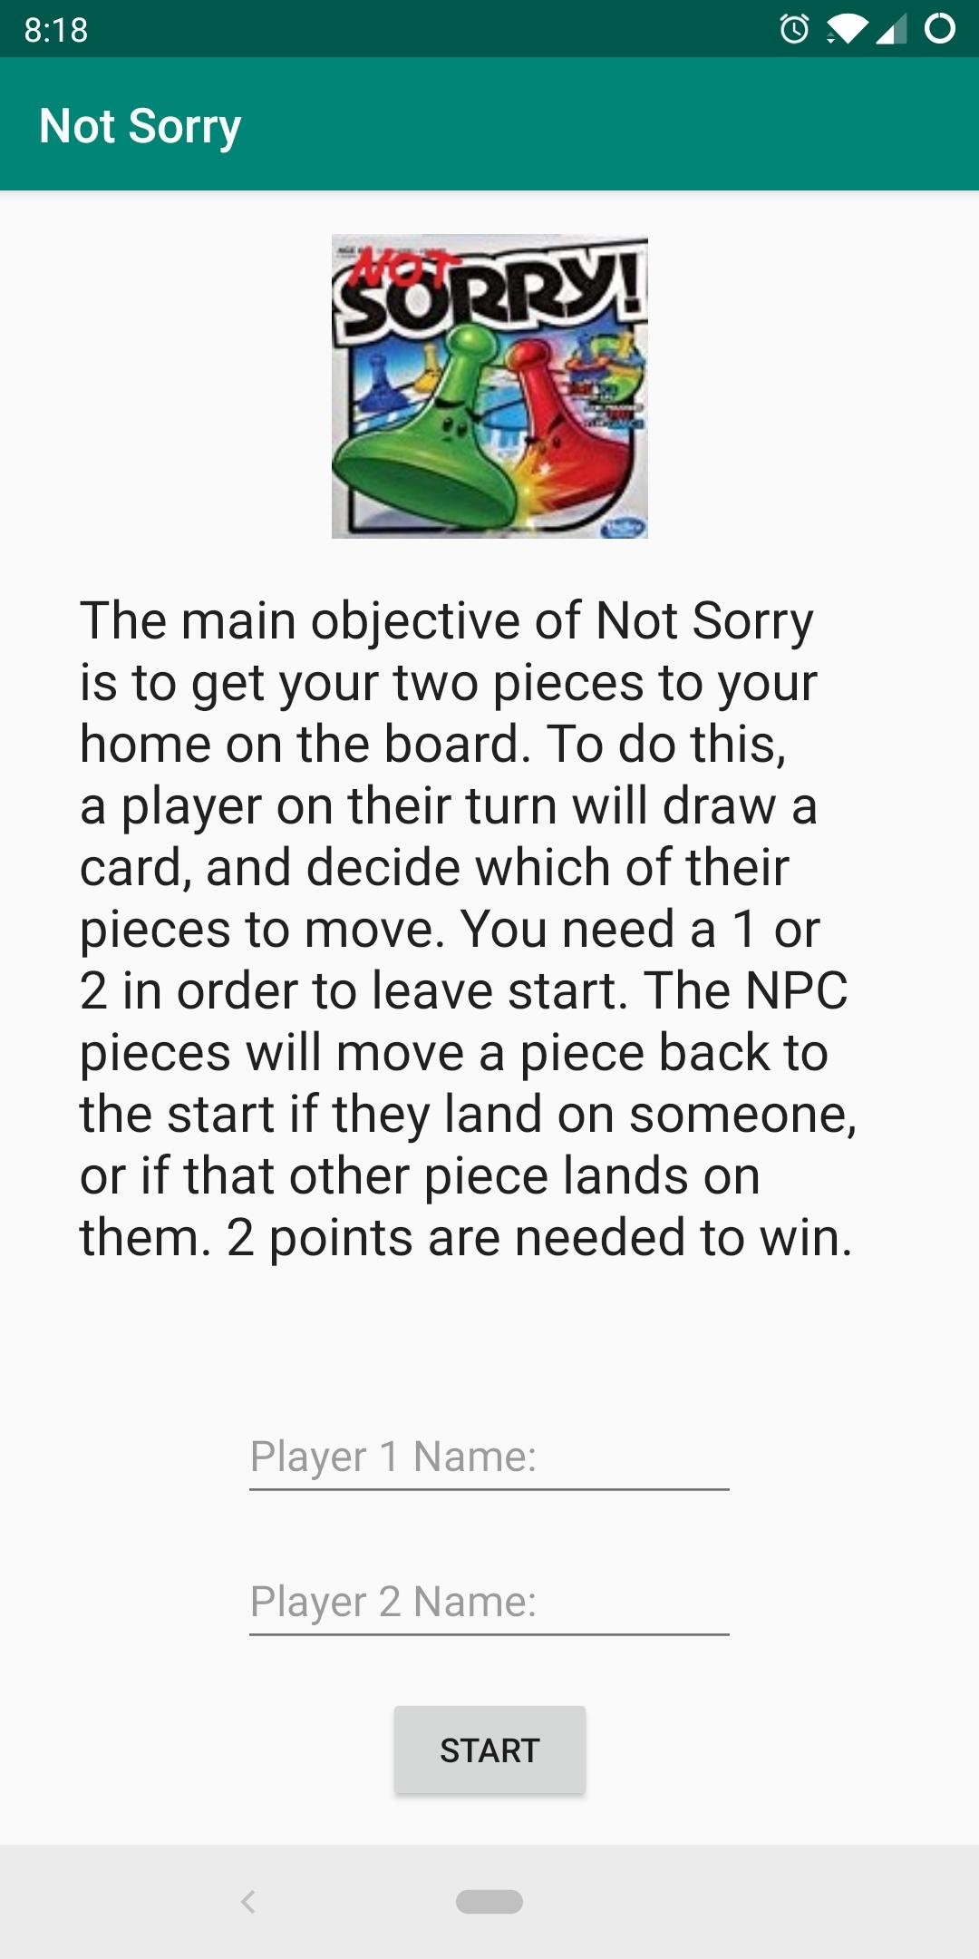 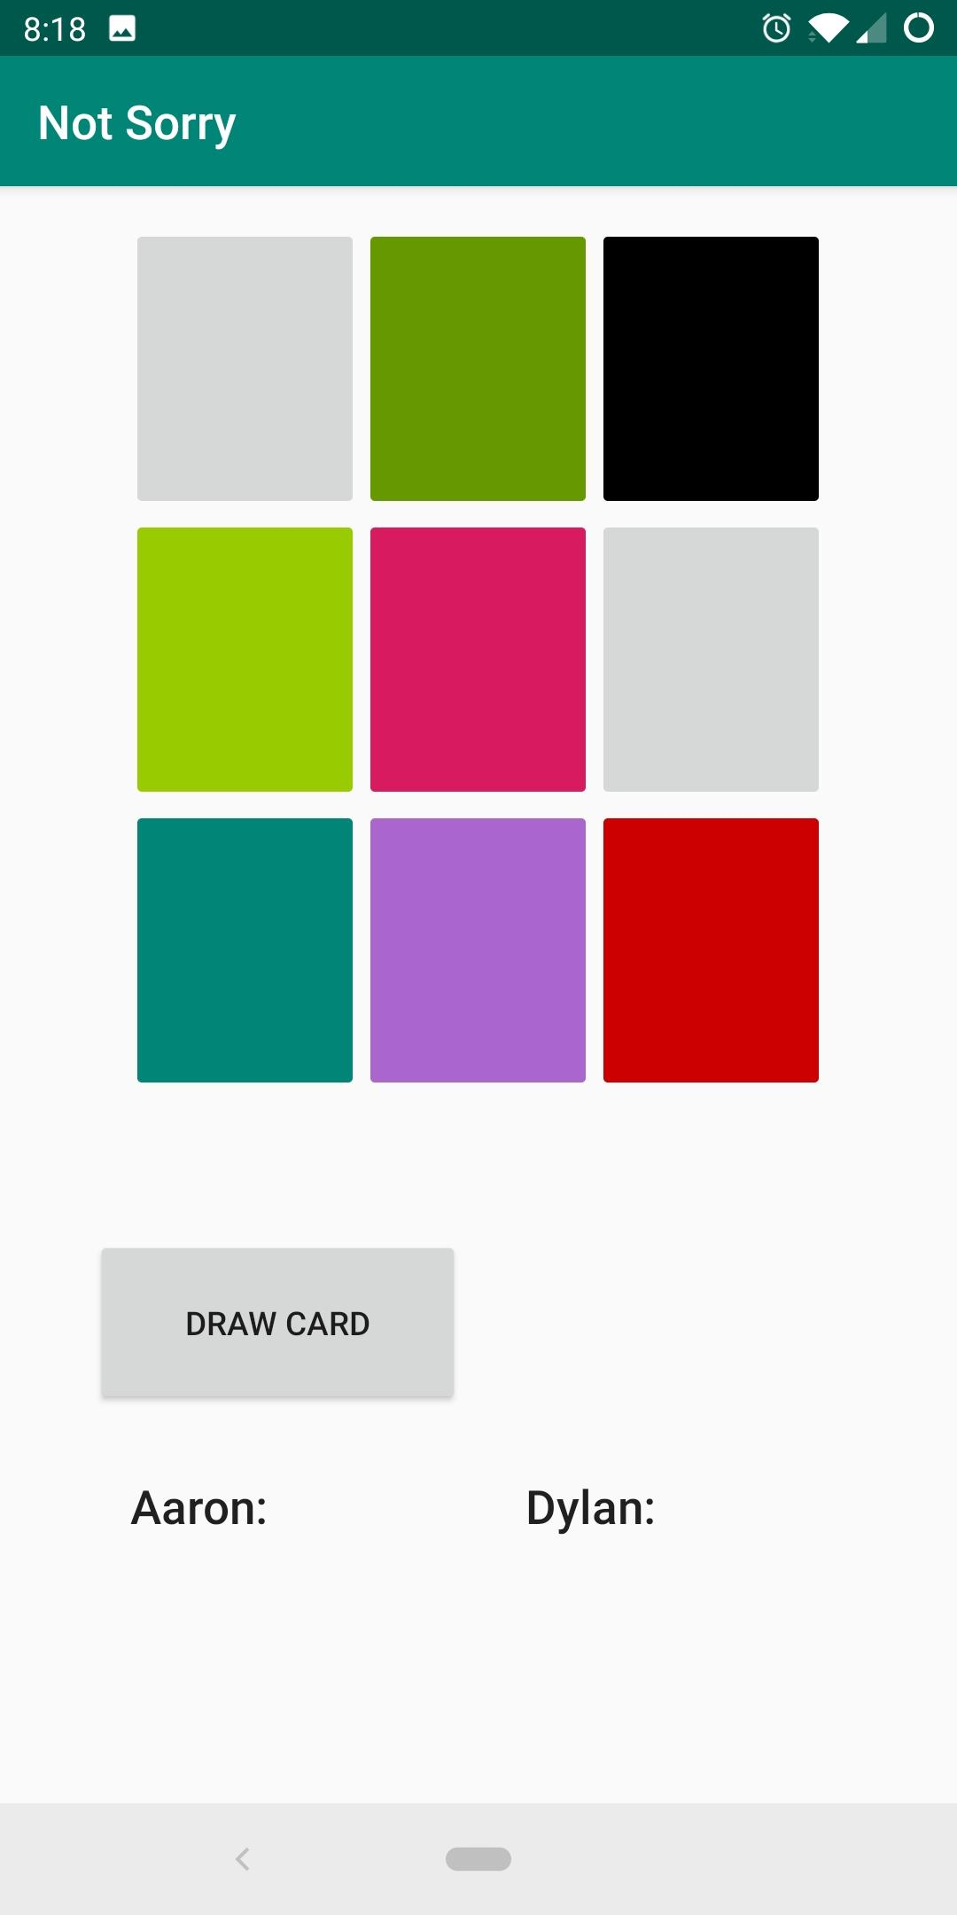

Sources

The only used copyrighted source was for the modified game image, where we took the box art for Sorry and used MS Paint to edit it. The original box art can be found [here](https://www.amazon.com/Hasbro-A5065-Sorry-Game/dp/B076HK9H7Z).